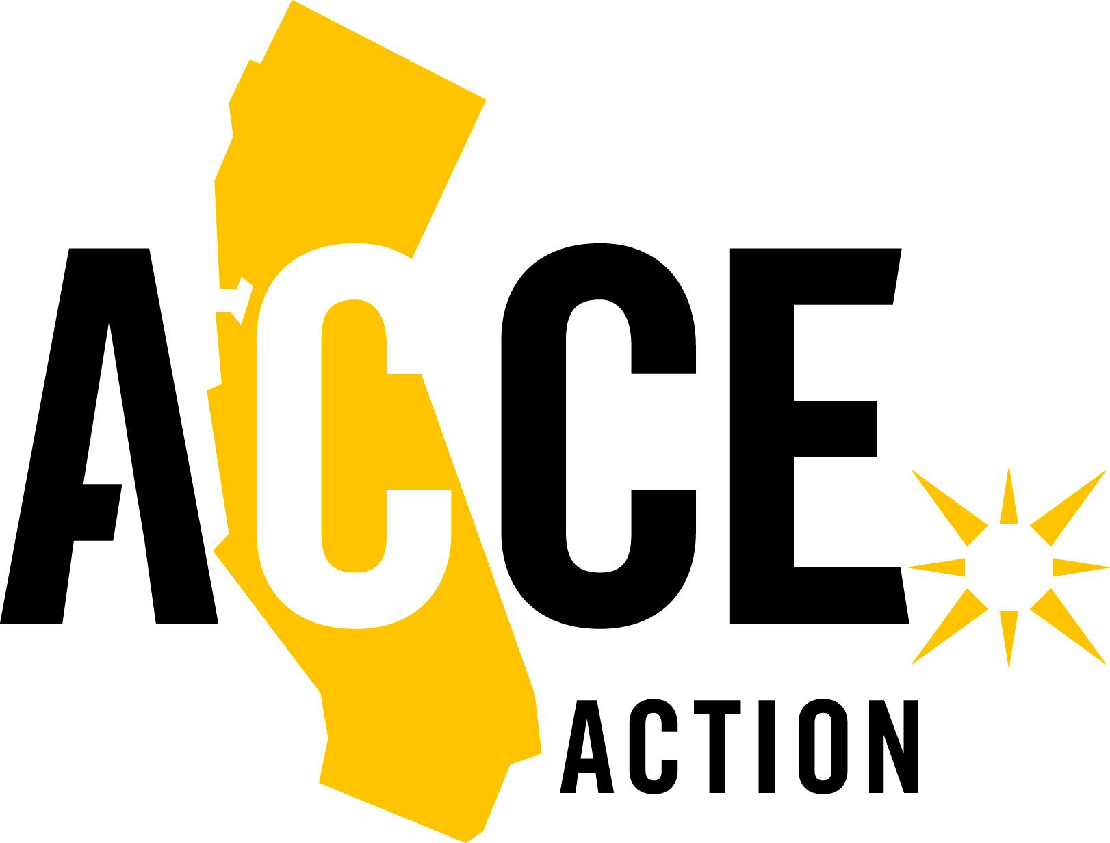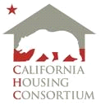

November 11, 2024

The Honorable Gavin Newsom
Governor of California
1021 O St., Ste. 9000
Sacramento, CA 95814

Senate President Pro Tempore Mike McGuire
1021 O Street, Suite 8518
Sacramento, CA 95814

Assembly Speaker Robert Rivas
1021 O Street, Ste. 8330
Sacramento, CA 95814

Assembly Budget Chair Jesse Gabriel
1021 O Street, Ste. 8230
Sacramento, CA 95814

Senate Budget Chair Scott Wiener
1021 O Street, Suite 8620
Sacramento, CA 95814

Re: 2025-26 Housing and Homelessness Priority Investments

Dear Governor Newsom, Senate President pro Tempore McGuire, Assembly Speaker Rivas, Assembly Budget Chair Gabriel, and Senate Budget Chair Wiener:

We write to you as a united coalition of California’s leading affordable housing, homelessness, and housing justice organizations to propose a set of priority investment areas that we encourage you to consider as the blueprint for investment in the 2025-26 budget.

We greatly appreciate the work that the Administration and the Legislature have done in recent years to address California’s housing and homelessness crises, and we share your commitment to ensuring that all Californians have a safe and affordable place to call home.

While the budget outlook for 2025 is still emerging, what is certain is the significant need to sustain our momentum in addressing California’s housing affordability and homelessness challenges. The need continues to be great, and proven programs must be prioritized in next year’s budget to continue to make progress in addressing these challenges. With funds from the last affordable housing bond depleted and the decision not to advance an affordable housing bond on the November 2024 ballot, General Fund investments in 2025-2026 are even more critical.

We are collectively calling for investments from the General Fund that build on the state’s recent progress by promoting the ongoing, long-term production and preservation of affordable housing needed to achieve the state’s ambitious housing goals; provide safe, affordable homes for millions of struggling lower-income Californians; offer housing and services for people experiencing homelessness; and address the disproportionate harms of skyrocketing housing costs, housing instability, and homelessness on Black, Indigenous, Latinx, and other people of color. We will also continue to work towards additional revenue streams for affordable housing and homelessness outside of the General Fund, including a statewide affordable housing bond in 2026.

The following existings programs should be prioritized for the 2025-2026 budget:

Tax Credits for Creating Affordable Housing
State Low-Income Housing Tax Credits (LIHTC) | - The State LIHTC provides critical gap funding so that California can fully utilize federal LIHTC.  - Over the first four years, the enhanced state LIHTC–funded through a $500 million annual commitment–has allowed developers to create an additional 25,000 homes affordable to low-, very low-, and extremely low-income households and allowed California to draw down an additional $5.3 billion in federal LIHTC.  - The $500 million allocated to the program in 2024-25 will be committed to new affordable housing developments in 2025, and no future credits are assured.
Affordable Housing Subsidy Programs
On average, the state contributes $148,120 per unit in subsidy to new affordable housing, while local, federal, and private sources fund the majority of project costs.
Multifamily Housing Program (MHP) | - MHP is the state’s primary affordable housing subsidy program for new construction and preservation of existing affordable housing.  - In the last two rounds of MHP alone (2022 and 2023), the program provided funding for over 3,100 new affordable homes.  - This year, our coalition is seeking an additional set-aside of funding through MHP to support the sustainability of existing state-funded affordable housing currently facing extreme financial risk due to operational challenges, primarily escalating insurance costs.  - The $315 million available to this program from the last budgets will be awarded in 2025, and no additional funding is available to MHP without additional General Fund commitment.
Joe Serna, Jr. Farmworker Housing Grant Program | - The program helps fund new construction, rehabilitation, and acquisition of owner-occupied and rental units for agricultural workers, with a priority for lower-income households.  - For eligible communities, these successful development projects involve multi-family home ownership and rental units, including single-family subdivisions, for lower-income agricultural employees and their families, and programs that assist lower-income agricultural employees and their families to become or remain homeowners.  - Serna has been consistently oversubscribed since its inception. Final existing Serna funds will be allocated in May 2025, and no additional funding is available for Serna without additional investment.
CalHome | - CalHome is the only state program that increases affordable supply of for-sale entry level homes, by including funding for the production of affordable single-and multi- family homes for purchase by qualified 100% lower-income first-time homebuyers and the rehabilitation of existing housing stock owned by lower-income earning households.  - The production of affordable ownership homes is a proven strategy to address California's housing crisis and prompt housing justice in urban, rural, and tribal communities, creating a path to intergenerational wealth and long-term stability.  - CalHome is oversubscribed by 100-300% each year – ranging from $90-175 million oversubscribed in the last several years, forcing shovel-ready project cancellations by nonprofit developers.  - The November 2024 round of CalHome awards will be disbursed in May of 2025, and all other remaining CalHome funds, $152.5M, were reverted from the 2024-25 budget. No additional funding is available for CalHome without additional investment.
Portfolio Reinvestment Program (PRP) | - The PRP is designed to preserve HCD-funded affordable housing projects that are at-risk of conversion to market-rate housing.  - The PRP was created and funded in the 2021-22 budget and, to date, has supported 29 developments and 1,352 units. A second round of awards is forthcoming.  - Approximately 33,910 affordable homes are at-risk of losing affordability in the next 10 years and 7,350 affordable homes may no longer be affordable, beginning as soon as 2025.  - The Legislature and Governor previously awarded PRP a total of $150 million in one-time funding. However, the final 2024-25 budget did not include additional funds for the program. The program currently has no available funds.
Infill Infrastructure Grant (IIG) Program | - The IIG program provides financial assistance for capital improvement projects that support infill housing development.  - In 2019, general fund dollars were allocated to the IIG program. Since 2019, it has supported over 215 projects essential to, or necessary for, housing development. Prior to 2019, Proposition 1C (2006) and Proposition 1 (2018) bond proceeds were used to fund the IIG program.  - Infrastructure improvements are often necessary to make housing development feasible. The IIG program plays a critical role in providing gap funding to promote infill development, which is important to helping the state meet its housing and climate goals.  - The final 2024-25 budget reverted $235 million from the IIG program. A final round of awards will go to projects through the IIG program in 2025. No additional funding will be available for the program beyond 2025 without additional investment.
Homelessness Program
Homeless Housing, Assistance and Prevention (HHAP) Program | - HHAP provides funding for local homelessness responses, and includes vital funding for homelessness prevention, shelter, services, and most critically, rental assistance for permanent housing.  - In recent rounds of HHAP, accountability measures were added to ensure local jurisdictions are collaborating across different levels of government, focusing resources on key state priorities, and tracking performance data.  - HHAP has served over 200,000 Californians through the first three rounds, and 40,000 people were able to exit homelessness for good since 2023. HHAP is the backbone of rural, urban, suburban, and tribal homeless responses: last year using HHAP, Butte County sheltered over 1,000 people, the Sacramento CoC sheltered 3,000 people, and the San Diego CoC helped over 500 households exit homelessness through permanent housing placements.  - No additional funding is available to HHAP without added investment in this year’s budget.  - This year, our coalition is seeking additional funding for rental assistance for older adults and people with disabilities at risk of and experiencing homelessness. Older adults and people with disabilities are the fastest-growing populations of Californians experiencing homelessness. These targeted funds would be administered through an existing program, such as HHAP, but would require new, additional investment.

Finally, while the State has not yet begun administering programs for the preservation of currently unsubsidized affordable housing (acquisition-rehabilitation preservation), we know this is an important strategy for homelessness prevention and anti-displacement, as well as adding to our affordable housing stock. We look forward to working with partners in the Legislature and the Administration to find a pathway forward to fund these critical projects.
With a renewed commitment from state leaders—and ongoing financial support for successful housing programs—California can enable the creation of nearly 47,000 shovel-ready affordable homes in the pipeline that are waiting on state funding, ensure that Californians who are unhoused do not remain homeless for months or years to access home, and prevent more marginalized Californians from falling into homelessness.

Our coalition stands committed to advocating for this complete package of housing and homelessness programs. Thank you for your ongoing leadership and partnership in creating a more affordable and equitable California. We look forward to working together closely on the budget over the next year.

Sincerely,

Alliance of Californians for Community Empowerment
California Coalition for Rural Housing
California Housing Consortium
California Housing Partnership
California Rural Legal Assistance Foundation
Corporation for Supportive Housing
Habitat for Humanity California
Housing California
Housing Now!
Enterprise Community Partners
National Alliance to End Homelessness
Non-Profit Housing Association of Northern California
San Diego Housing Commission
Western Center on Law and Poverty

Enterprise Community Partners. “The California Affordable Housing Pipeline,” April 2024. https://www.enterprisecommunity.org/sites/default/files/2024-04/State_Pipeline%20_2024_FINAL_0417.pdf
California Housing Partnership. “Affordable Homes at Risk,” April 2024. https://chpc.net/wp-content/uploads/2024/04/Subsidized-At-Risk-Report_April-2024.pdf
Data according to State’s Homeless Data Integration System: https://public.tableau.com/app/profile/california.business.consumer.services.and.housing.agency/viz/HHAPReport/Overview

